CSS is the language we use to style a Web page.

**What is CSS?**

* CSS stands for Cascading Style Sheets
* CSS describes how HTML elements are to be displayed on screen, paper, or in other media
* CSS saves a lot of work. It can control the layout of multiple web pages all at once
* External stylesheets are stored in CSS files

**CSS Syntax:**

A CSS rule set consists of:

* **Selector:** Identifies the HTML element(s) to style.
* **Property:** Specifies the aspect to style (e.g., color or font-size).
* **Value:** Defines the style (e.g., blue or 16px).

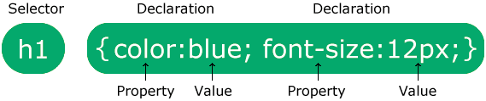

Example :

p {

color: blue;

font-size: 16px;

}